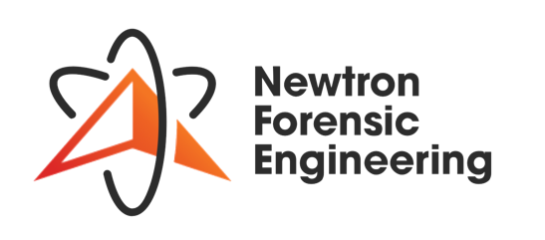

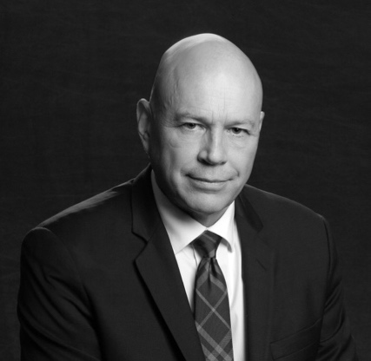

# Contact

[cgiffin@newtronfe.ca](mailto:cgiffin@newtronfe.ca)

416 452 8099 (Cell)

1-800-238-3734 (TF)

LinkedIn/in/cmgiffin

302 Bay St., Suite 411 Toronto, ON M5H 0B6

Newtronfe.ca

# Education & Training

University of Waterloo, Bachelor of Applied Science: Civil Engineering, 1988

Strategic Coach with Dan Sullivan, Entrepreneurship / Executive Management, 2011 – 2013

**Chris Giffin,** P. ENG

President & CEO

A visionary who executes success in forensic engineering by building on a foundation of independence, depth and breadth of expertise, industry-leading mentorship and dedication to unbiased forensics that recognizes client needs. Specializes in developing Canadian and international multi-million-dollar large-loss forensic engineering practices, creating progressive and unique service offerings for the legal and insurance industries. Generates excitement for a compelling vision and strategy that inspires execution, leading optimized operations, strategic service offering development, business excellence and enduring customer relationships.

Areas of expertise: strategic planning, accelerated profitable growth, corporate culture, engaging leadership, progressive marketing, finance and corporate governance.

* Collision Reconstruction & Road Safety
* Biomechanics & Human Factors
* Multi-disciplinary Large Loss Property & Liability
* Construction Claim Disputes
* Environmental Contamination
* Loss Remediation Consulting
* Material & Product Failure
* Renewable Energy
* Forensic Accounting
* Computer Forensics

Experience

President & CEO

Newtron Forensic Engineering Inc. 2025 – Present

* Provide strategic leadership and oversight of operations, business development, client relationships, and team growth to establish Newtron Forensic Engineering as a trusted industry leader.
* Ensure service excellence across core forensic offerings by delivering precise, neutral, and scientifically rigorous analyses that support confident client decision-making.

President & CEO

Giffin Corp. - 2001 – Present

* Develops globally differentiated forensic engineering solutions for large, complex losses and oversees multi-disciplinary investigations, reporting, and client engagement.
* Provides business management consulting in strategy, HR, operations, finance, sales, and marketing while mentoring entrepreneurs and fostering leadership growth.

President & CEO

Haag Canada. May 2020 – Dec 2021

* Partnered with Haag Global to launch Haag Canada, establishing three offices, 12 professionals across five engineering disciplines, and new service offerings during the COVID-19 pandemic.
* Positioned Haag Canada as an independent, unbiased large-loss forensic resource, creating unique offerings that resonated with the Canadian marketplace.

Founder / CEO / President / Owner

30 - Forensic Engineering (Formerly Giffin Koerth Forensic

Engineering) - 2002 – 2018

* Founded and scaled Canada’s largest independent forensic engineering firm to ~100 staff and $15–18M in revenue, creating a Global Centre of Excellence for large-loss investigations.
* Built corporate infrastructure with HR, marketing, PR, and advanced technologies, while implementing peer-reviewed, unbiased reporting processes and innovative remote-enabled research facilities.

President / CEO

Walters Forensic Engineering - 1999 – 2001

* Implemented a five-year financial transformation plan, eliminating unprofitable branches, restructuring operations, and redirecting resources into core services.
* Achieved a strong financial turnaround, exceeding growth and profitability goals within the first year.

Professional Affiliations

* 30 Forensic Engineering: www.30FE.com
* Professional Engineers of Ontario: www.peo.on.ca
* Canadian Society of Forensic Sciences: www.csfs.ca
* ADR Institute of Ontario: [www.adric.ca](http://www.adric.ca)
* Consulting Engineers of Ontario: [www.ceo.on.ca](http://www.ceo.on.ca)
* Honorable Order of the Blue Goose: www.bluegoose.org

Toronto Branch Manager - 1995 – 1999

* Modernized operations and rebuilt the firm’s reputation as an unbiased forensic resource, expanding expertise in large-loss investigations.
* Introduced improved operational standards that drove significant growth and supported long-term market expansion.

Consulting Forensic Engineer - 1988 – 1994

* Conducted residential and small commercial building failure analysis, construction claims, fire investigation, and vehicle collision reconstruction.